1. Summarize chapters 7 and 8 in the text book.

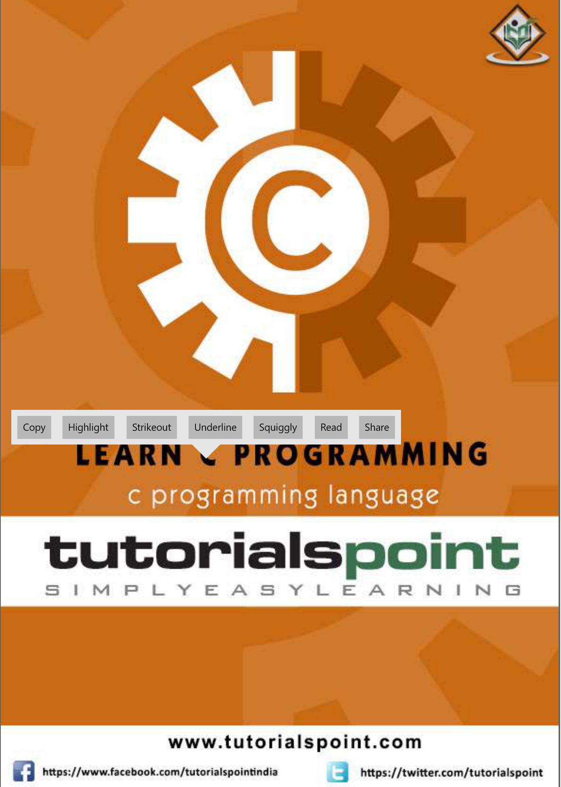

1. Submit your own program based on all the sample codes in each chapter 8 provided in the textbook and **PDF file**. And take a picture of the solutions and attach the picture to the assignment file.